**PROJECT ON**

**DIGITAL MARKETING**

**HOW TO CREATE BRAND NAME, BRAND MAIL**

**AND BRAND LOGO IN CANVA**

Submitted By

KAVIYA S (46F70892EEC01EBBF1D458DD8014ECD9)

VARSHINI B (978AC184D091F2ABD8E49AEAD12716D4)

VINO PRIYADHARSHINI C (2A37B4456F01B7B8C104B54A6933D615)

TUSLIMA NASREEN S (B84FCF5B3C55E329DA945398792C114D)

**TEAM ID :** NM2023TMID03435

**BACHLOR OF ENGINEERING**

**IN**

**COMPUTER SCIENCE AND ENGINEERING**

**DHANALAKSHMI SRINIVASAN INSTITUTE OF**

**TECHNOLOGY**

**PROJECT DESCRIPTION**

BRAND NAME : ziva vogue

CATEGORY :Clothing Brand

TARGET AUDIENCE :All( Men, Women and Kids)

EMAIL :[zivavogue@gmail.com](DIGIT%20MARKETING.docx)

LOGO THEME :Related Clothing Brand-

Orange

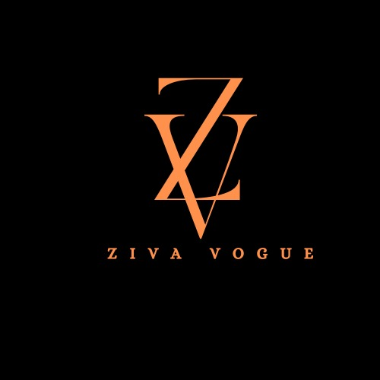

**RECORDED VIDEO**

[https://drive.google.com/file/d/16MVqHZ7U3cgAo0vm3tnf3AHiQmS1j-wc/view?usp=drivesdk](DIGIT%20MARKETING.docx)

**CREATE BRAND MAIL**

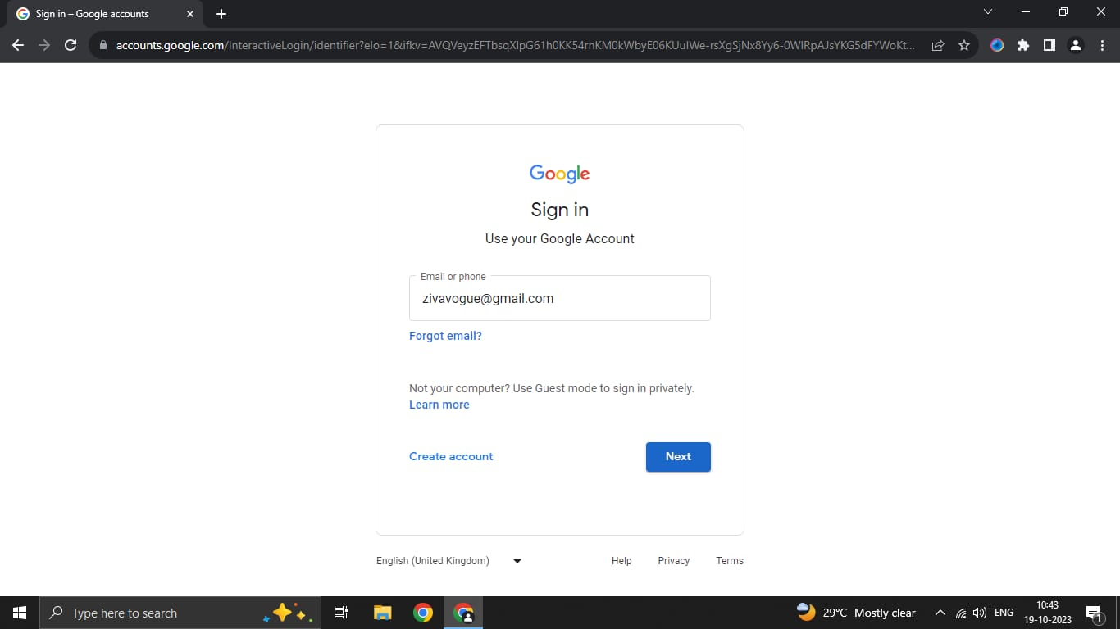

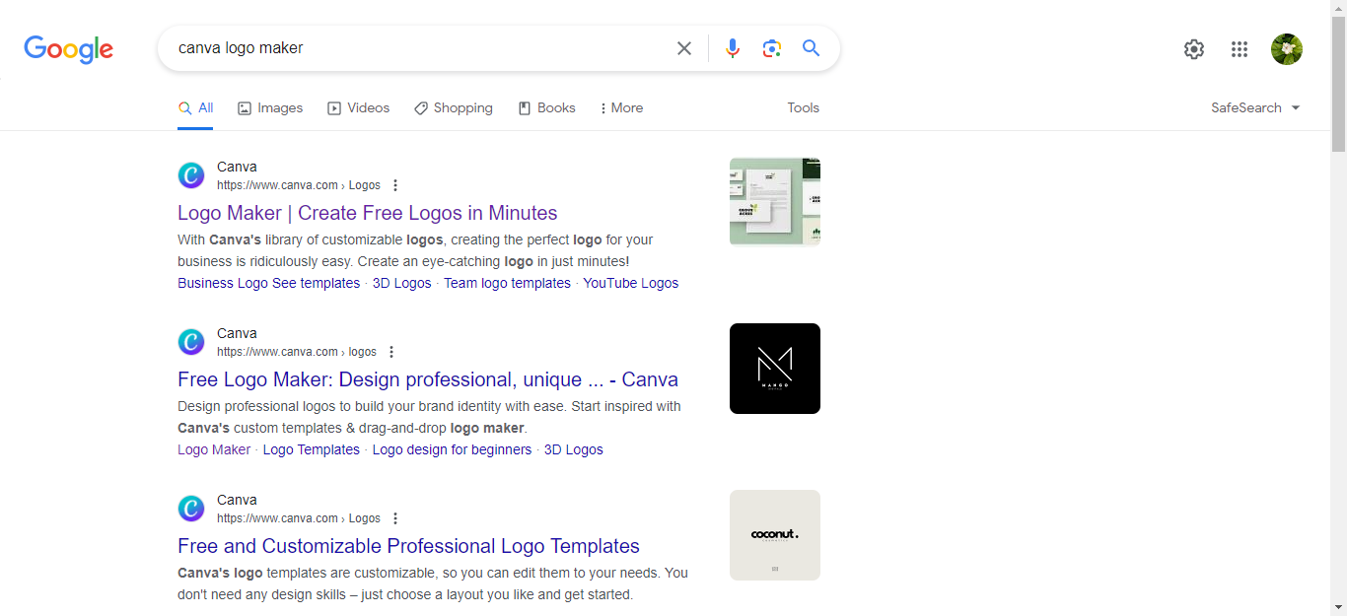**CREATE BRAND LOGO DESIGN USING CANVA**

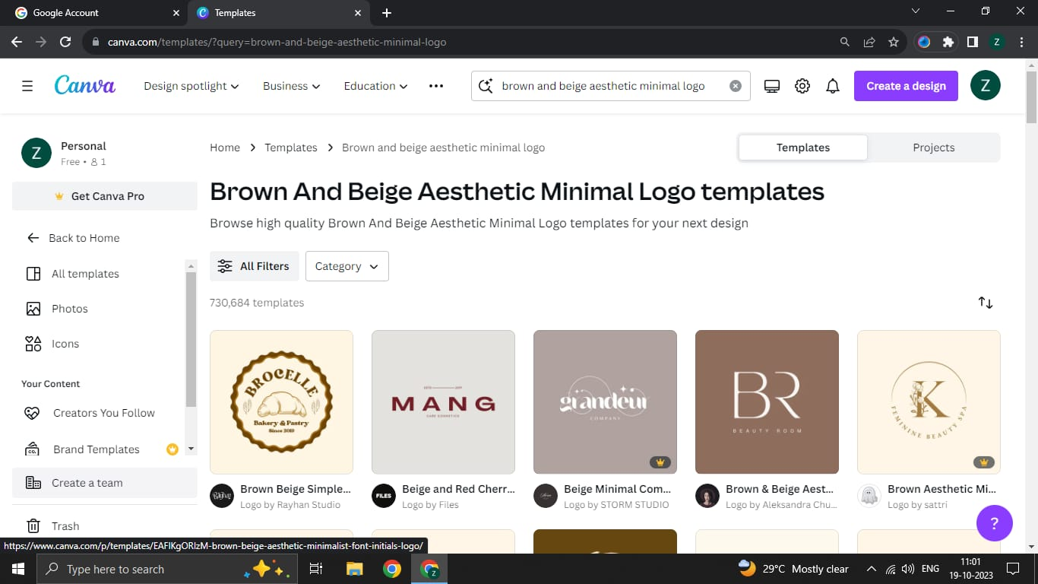**START TO DESIGN LOGO**

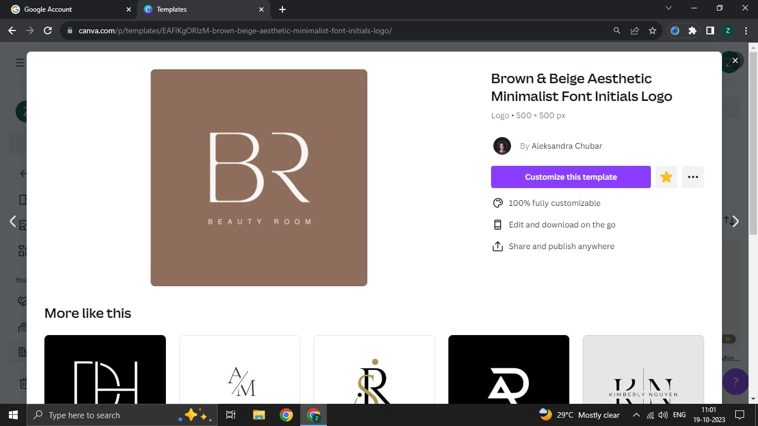**SELECT LOGO TEMPLATE**

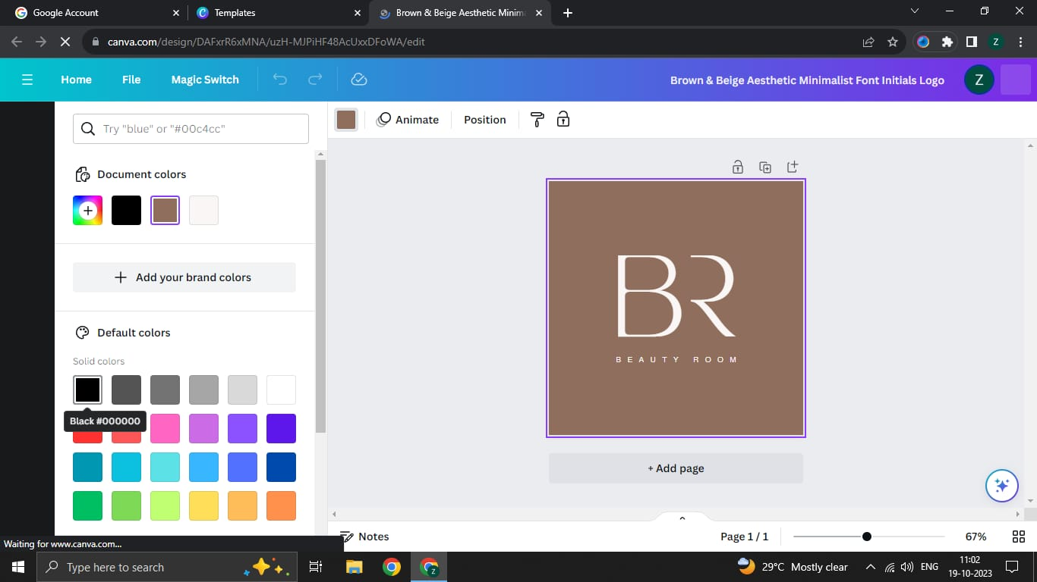**START TO EDIT BRAND LOGO**

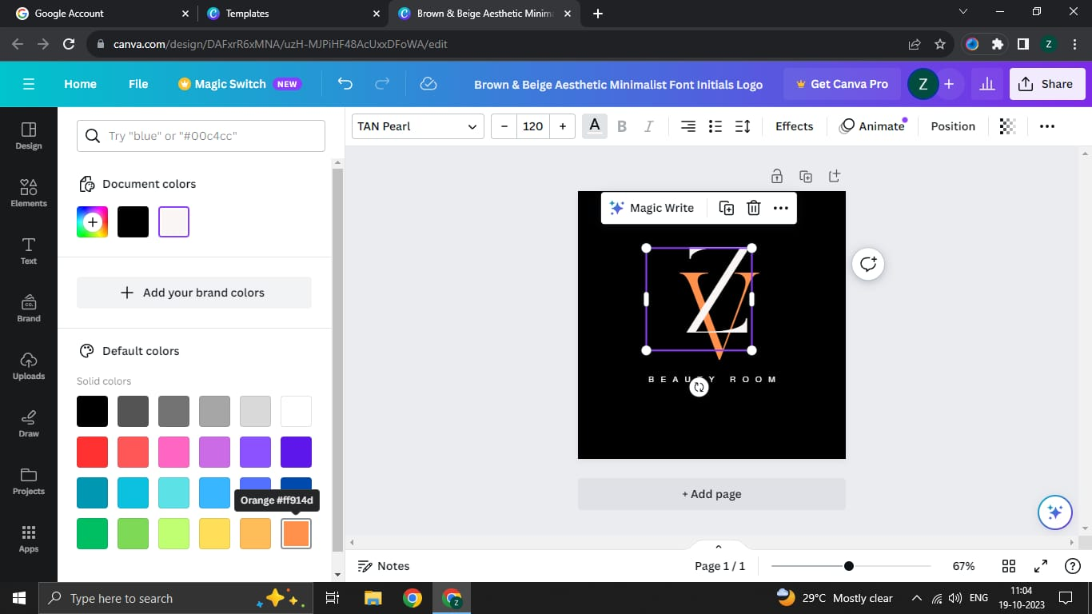**CREATE A BRAND LOGO**

**CHANGE BACKGROUND COLOR**

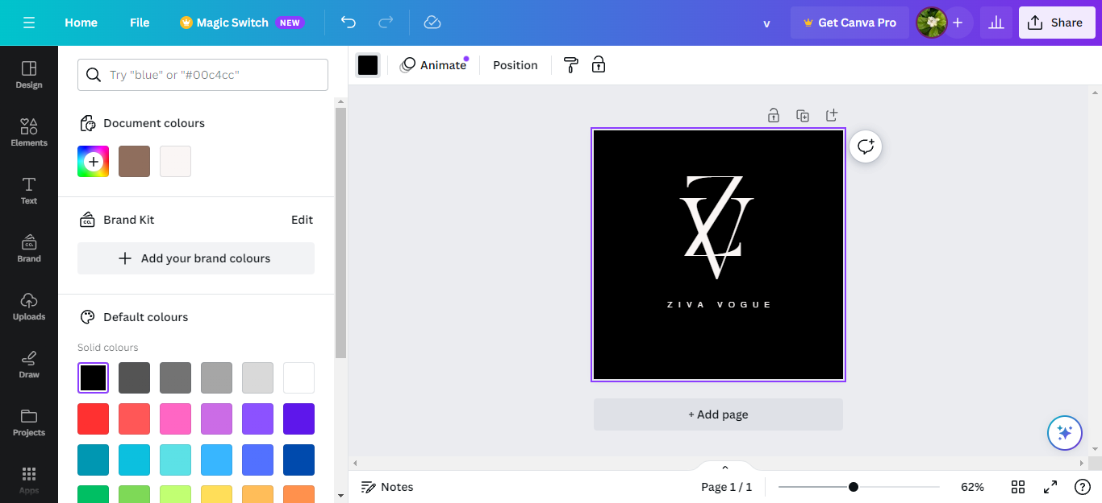

**BRAND LOGO**

